Ethical Model Prediction for Amazon Sales Dataset
Rahaf Alharbi,¹ Byader Alsulami,¹ Retal Marwan,¹ and Layan Abdullah¹
¹Department of Information Systems and Technology, College of Computer Science and Engineering,
University of Jeddah, Jeddah, Saudi Arabia
(Final Project Report – CEDS 323 Professionalism and Reporting, 2025)

Abstract: This study presents a comparative evaluation of three machine learning algorithms—Linear Regression, Decision Tree, and Neural Network—applied to the Amazon Sales Dataset for product rating prediction. Using SAS Viya Model Studio, a dataset of 1,566 observations and 21 variables was preprocessed, explored, and modeled. Linear Regression achieved the best performance (ASE = 0.0653, RASE = 0.2555) and was selected as the Champion Model. Discount percentage was identified as the strongest predictor of product rating.
Keywords: linear regression; decision tree; neural network; Amazon sales; rating prediction; SAS Viya

I. INTRODUCTION
In this project, our group aims to compare three different machine learning algorithms using one dataset. Each algorithm learns from data in a different way, so their results are not always the same. Because of that, it is important to test them on the same dataset and see which one gives better predictions.
The goal of this project is to use three machine learning algorithms on our dataset and compare their performance to see which model gives the most accurate predictions. Our dataset contains product reviews, ratings, prices, discounts, and information about each product. By analyzing these variables, we want to understand what factors may affect the product rating and how well each model can predict it.
The remainder of this report is organized as follows. Section II describes the dataset and data understanding. Section III presents the methodology. Section IV reports the results and analysis. Section V discusses the findings. Section VI concludes the paper with recommendations.
II. DATA UNDERSTANDING
2.1 Data Description
The dataset used in this study is the Amazon Sales Dataset, sourced from Kaggle [1]. It contains information about 1,000+ Amazon products including their ratings, reviews, prices, discounts, and product details. Table I summarizes the dataset characteristics.
Table I. Dataset Description
Attribute | Description
Title | Amazon Sales Dataset
Source | Kaggle
Observations | 1,566
Variables | 21
Data Types | Numerical and Textual

2.2 Data Preparation and Preprocessing
Data preparation was performed using SAS Viya [2]. Missing values were found only in Rating and Rating_Count and were replaced with the mean using the Standardize Data task. Outlier and duplicate checks confirmed the dataset was clean, requiring no further treatment. Figure 1 shows the missing data frequency analysis.
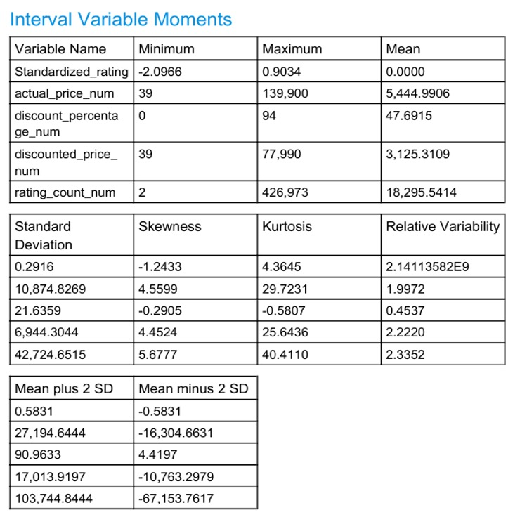
Fig. 1. Missing data frequency analysis (Rating and Rating_Count).
2.3 Exploratory Data Analysis (EDA)
EDA was performed to explore patterns and relationships between dataset variables.
Descriptive Statistics. Table II presents summary statistics for all numeric variables. Standardized_rating has a mean of 0 and ranges from −2.1 to 0.9. Actual price averages 5,445 with a range from 39 to 139,900. Discount percentage averages 48% (0–94%). Rating count is highly skewed with a mean of 18,295 and standard deviation of 42,725.
Table II. Descriptive Statistics for Numeric Variables
Variable | Min | Max | Mean | Std Dev
Standardized_rating | −2.10 | 0.90 | 0.00 | 0.29
actual_price_num | 39 | 139,900 | 5,444.99 | 10,874.83
discount_percentage_num | 0 | 94 | 47.69 | 21.64
discounted_price_num | 39 | 77,990 | 3,125.31 | 6,944.30
rating_count_num | 2 | 426,973 | 18,295.54 | 42,724.65

Rating vs. Discount Percentage. As shown in Figure 2, ratings range between 2.0–5.0 (mean = 4.1). Low discounts (2%) correlate with high ratings, while high discounts (86%) correlate with low ratings, confirming a weak negative relationship.
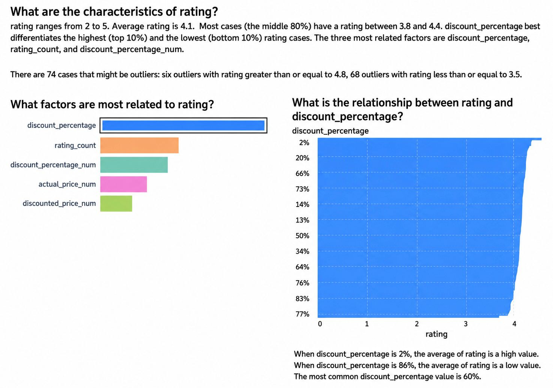
Fig. 2. Rating vs. discount percentage.
Rating vs. Rating Count. As shown in Figure 3, products with Rating_Count above 200k consistently achieve ratings above 4.0, confirming a weak positive relationship.

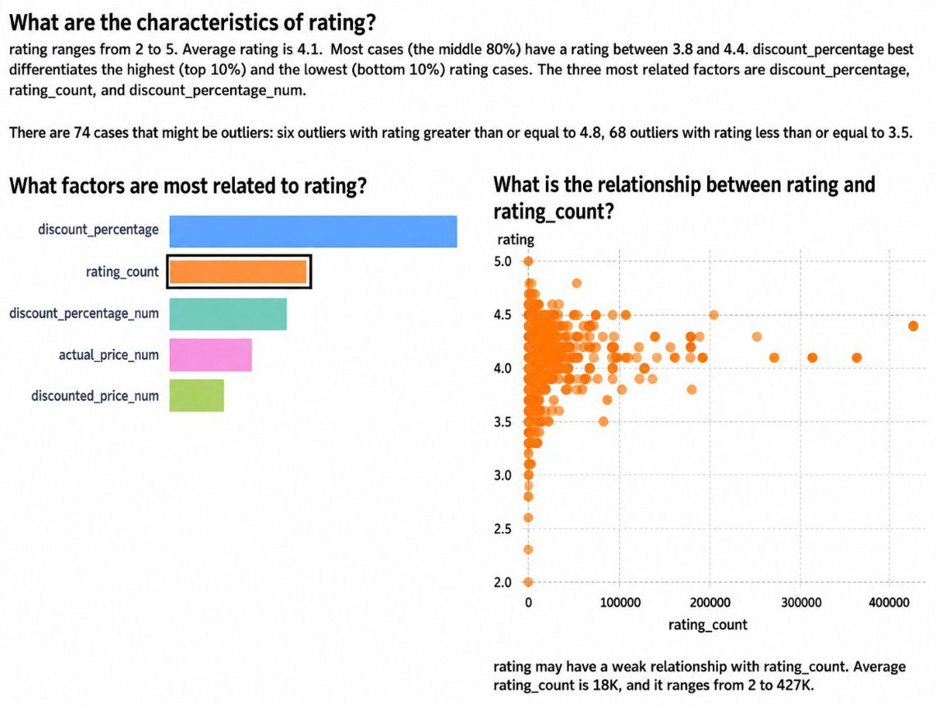
Fig. 3. Rating vs. rating count.
Rating vs. Discount Percentage Number. As shown in Figure 4, products with low or no discounts tend to have higher ratings, while moderate to high discounts correlate with lower ratings.

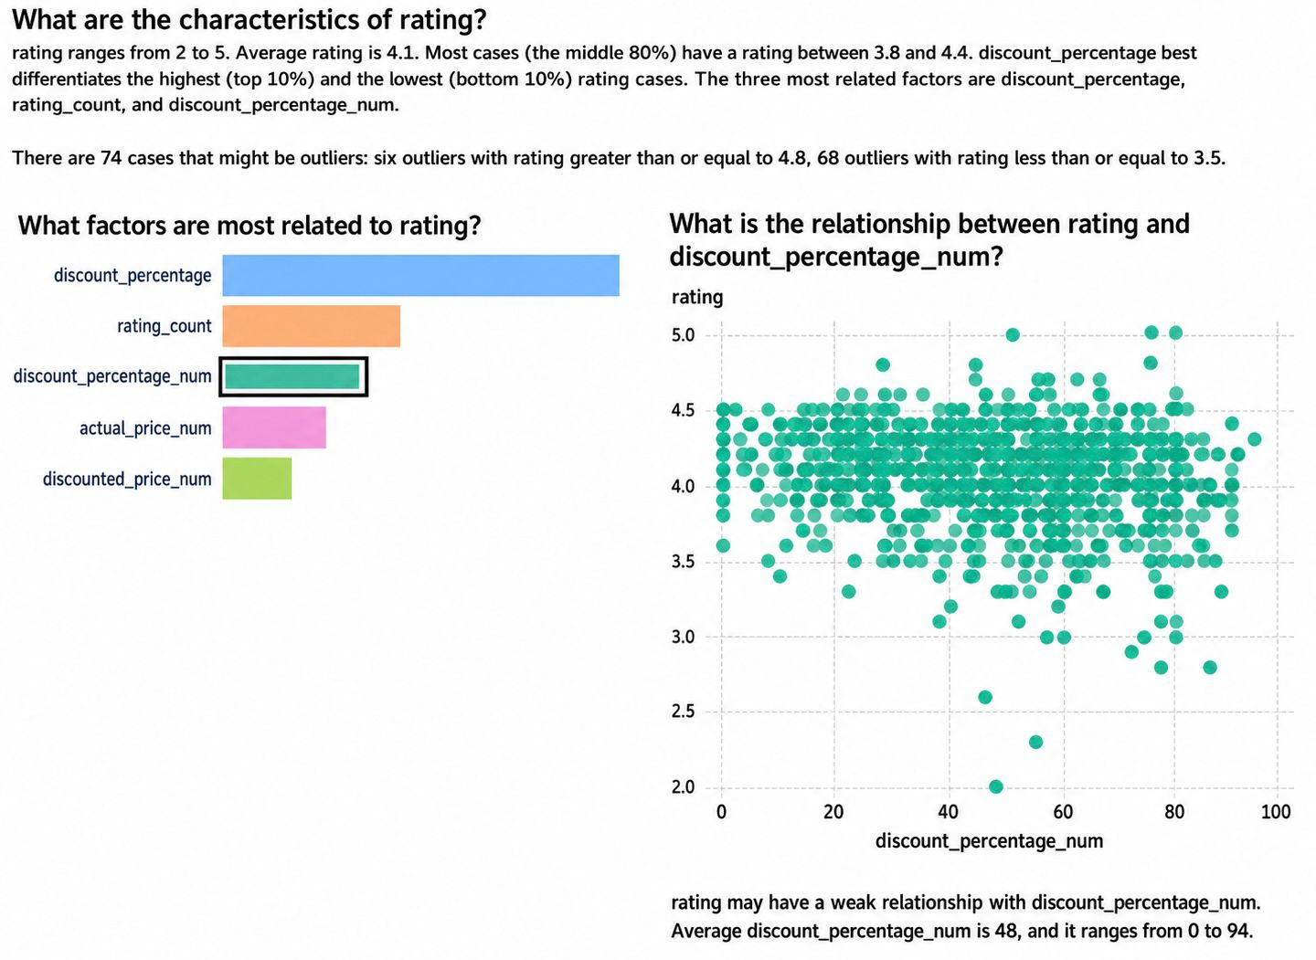
Fig. 4. Rating vs. discount percentage number.

Correlation Matrix. As shown in Figure 5, Discounted_Price_Num and Actual_Price_Num have the strongest correlation (r = 0.9619), Rating shows only weak correlations with all other variables.

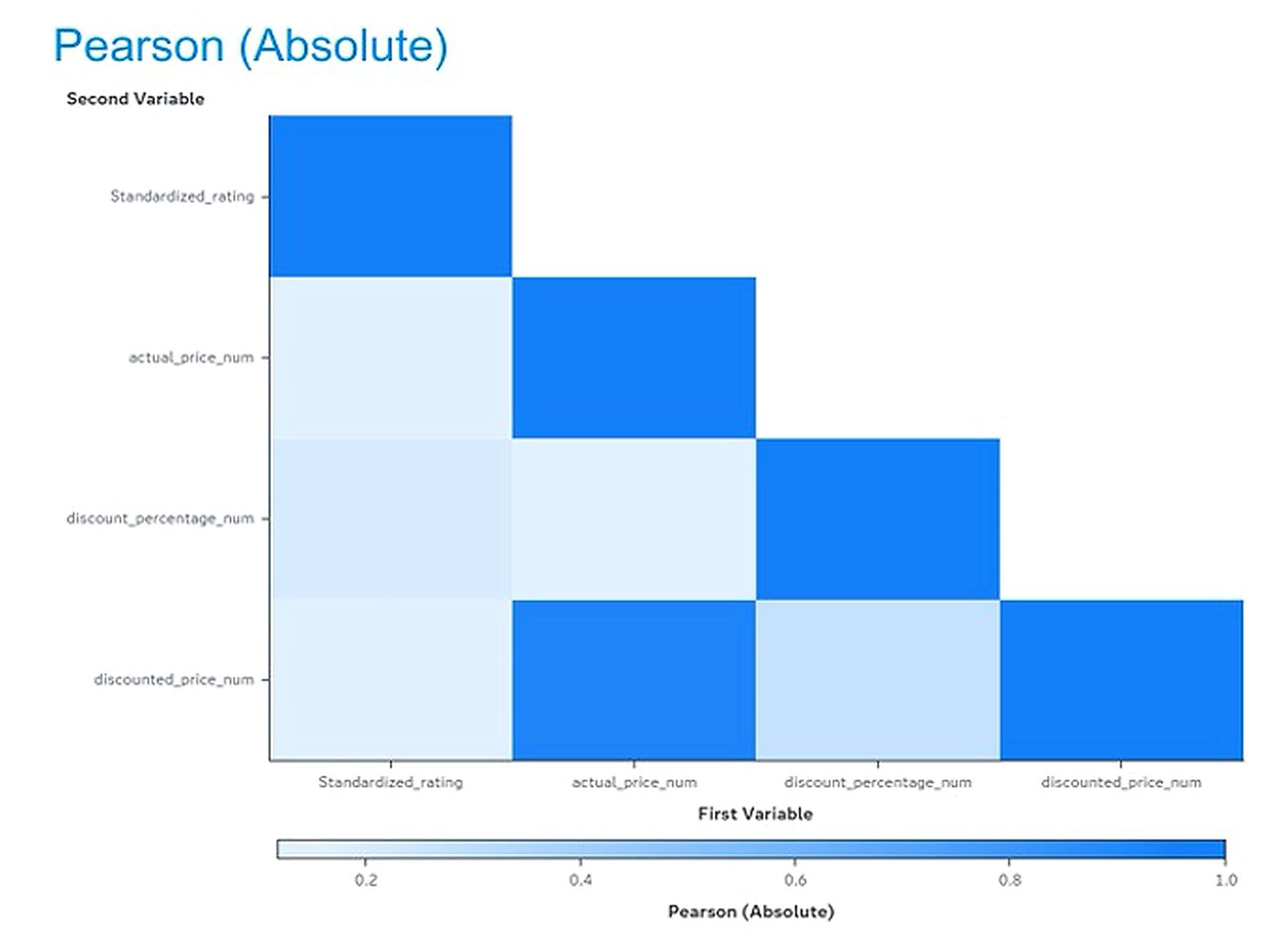
Fig. 5. Pearson correlation matrix.
Standardized Rating Distribution. As shown in Figure 6, the distribution is approximately normal and centered near zero, indicating most products receive average ratings around 4.1 with very few extreme outliers.

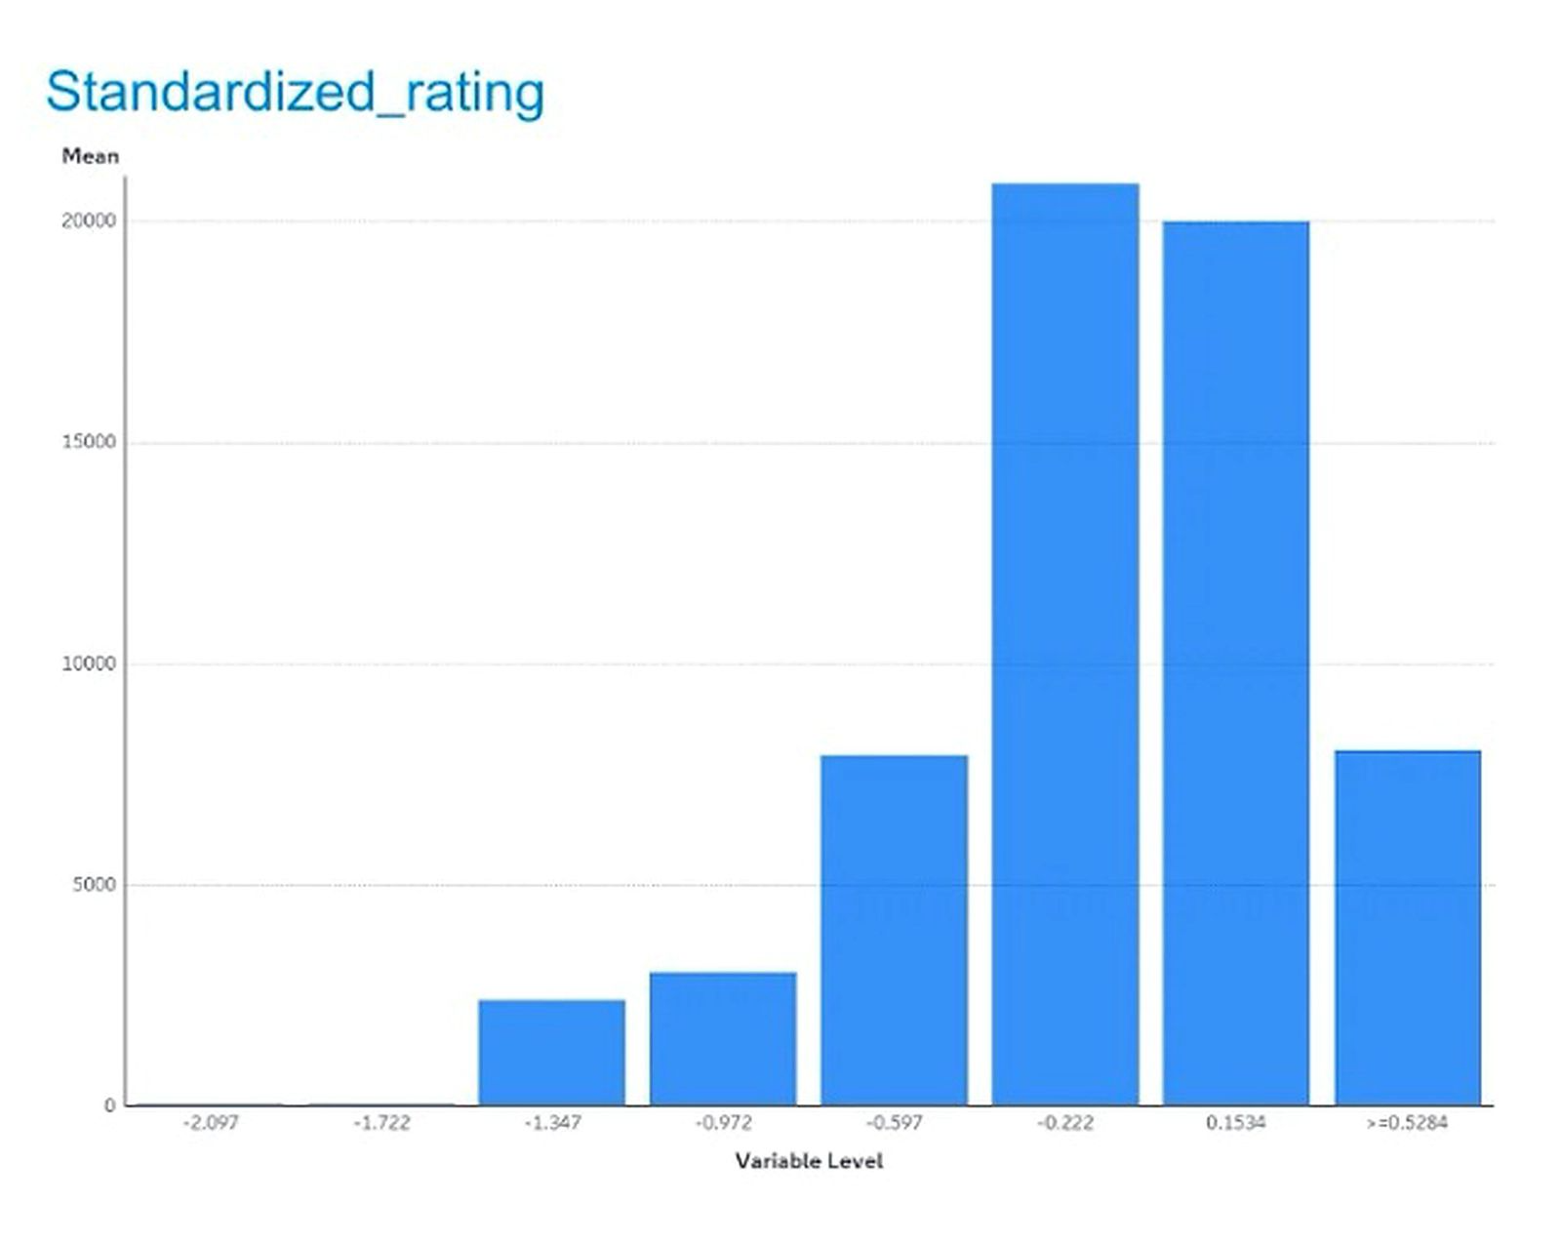
Fig. 6. Standardized rating distribution.
III. METHODOLOGY
3.1 Data Preparation
Data preparation included checking for missing values, outlier values, and duplicate records. There were no duplicated rows or extreme outliers and all missing values were handled, so the dataset was clean and ready for modeling.
3.2 Model Setup
All three models were trained on the same dataset. Table III summarizes the configuration. Figure 7 shows the SAS Viya pipeline.
Table III. Model Setup Configuration
Item | Description
Target Variable | Standardized_rating
Input Variables | actual_price_num, discounted_price_num, discount_percentage_num, rating_count_num
Algorithms | Linear Regression, Neural Network, Decision Tree
Tool | SAS Viya Model Studio [2]

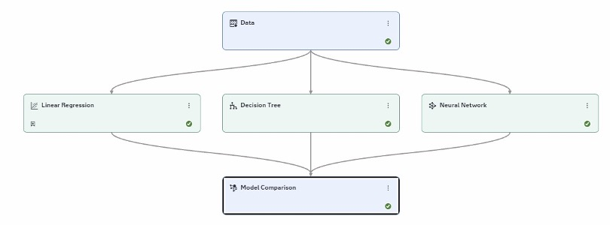Fig. 7. SAS Viya Model Studio pipeline.

3.3 Data Split

The dataset was split into 80% for training and 20% for testing using simple random sampling.
3.4 Evaluation Metrics
All models were evaluated using the following metrics:
• Average Squared Error (ASE)
• Root Average Squared Error (RASE)
• Root Mean Absolute Error (RMAE)
• Root Mean Squared Logarithmic Error (RMSLE)
3.5 Algorithm Justification
• Linear Regression: provides a simple baseline for linear relationships.
• Decision Tree: captures non-linear patterns and reveals variable importance.
• Neural Network: handles complex, non-linear relationships.

IV. RESULTS AND ANALYSIS
4.1 Variable Importance Analysis
Variable importance analysis identified Discount_Percentage, Rating_Count, and Discount_Percentage_Num as the top predictors. As shown in Figure 8, discount_percentage_num has the highest relative importance. Figure 9 confirms this via entropy reduction analysis.
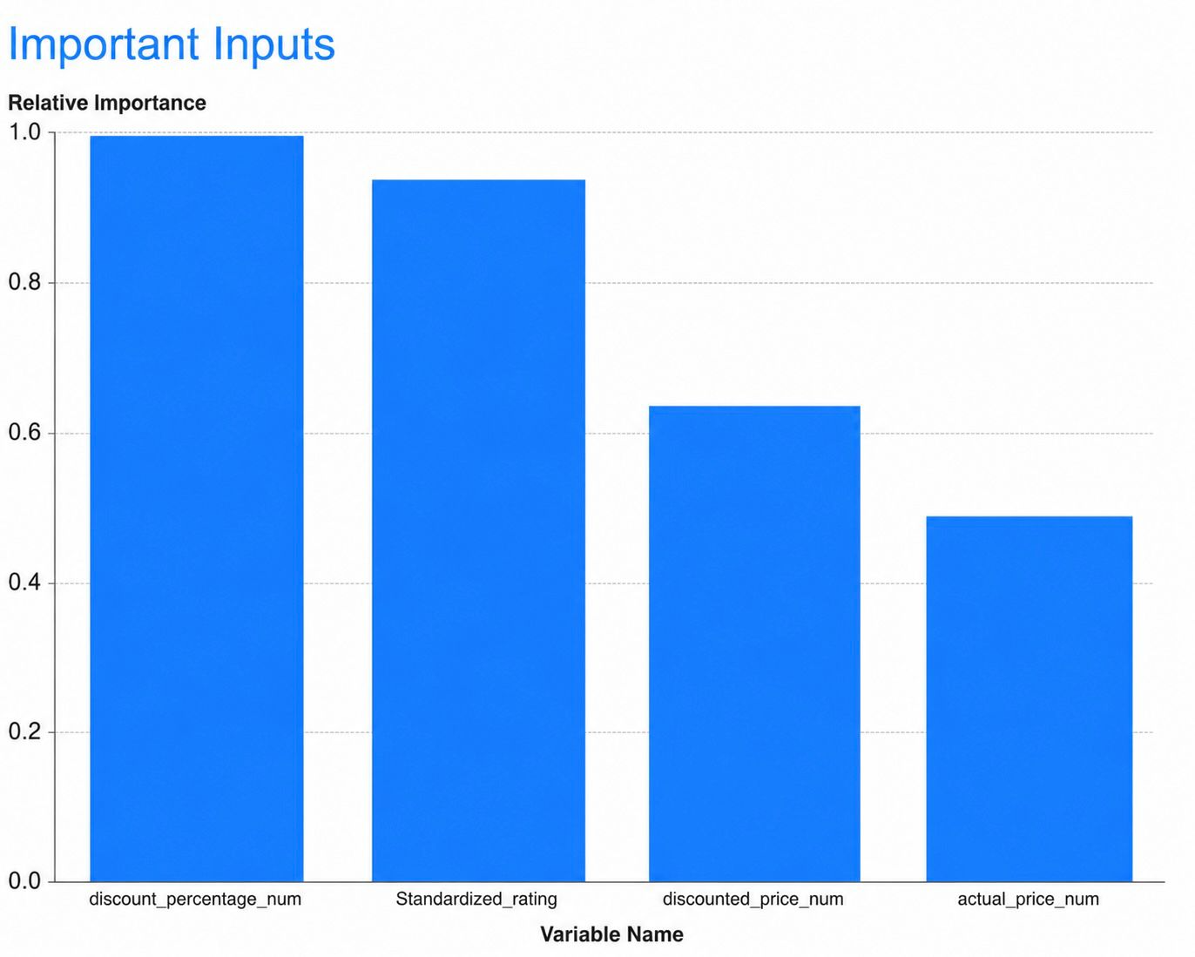
Fig. 8. Relative importance of input variables.

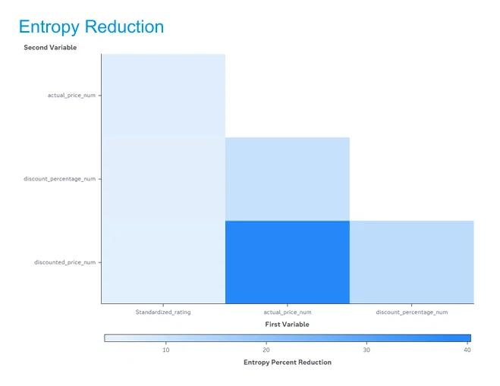 Fig. 9. Entropy reduction chart.
4.3 Model Comparison Results
Table V presents the full model comparison results. As shown in Figure 11, Linear Regression was selected as the Champion Model with the lowest error across all metrics.
Table V. Model Comparison Results on Test Set (n = 147)
Algorithm | Champion | ASE | RASE | RMAE | RMSLE
Linear Regression | ✓ Yes | 0.0653 | 0.2555 | 0.4460 | 0.5403
Decision Tree | No | 0.0674 | 0.2596 | 0.4530 | 0.5385
Neural Network | No | 0.0695 | 0.2635 | 0.4525 | 0.5504

4.2 Correlation Analysis
Figure 10 shows the Pearson correlation between input variables and Standardized_rating. No single variable has

a strong relationship with the target. Table IV summarizes the values

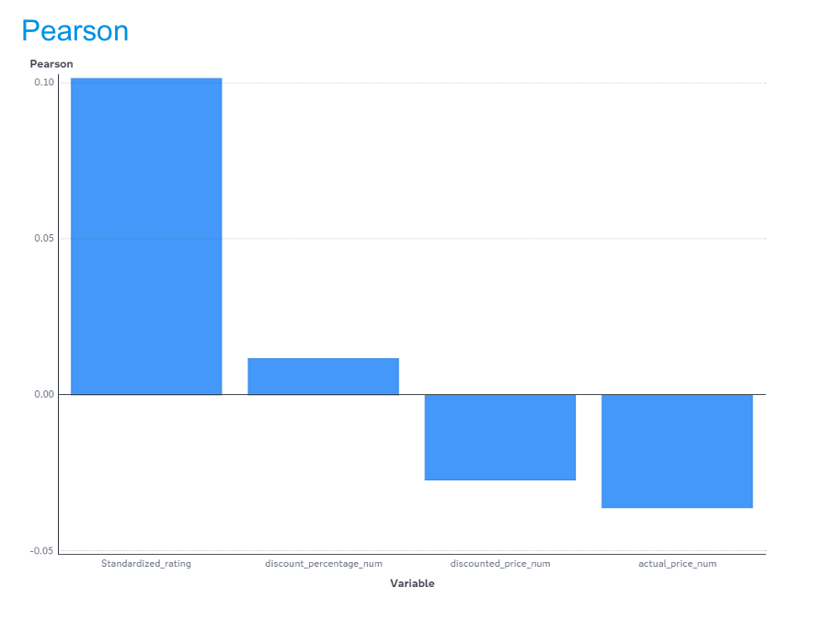

Fig. 10. Pearson correlation with Standardized_rating.

Table IV. Pearson Correlation with Standardized_rating
Variable | Correlation | Direction
discount_percentage_num | ≈ 0.01 | Very weak positive
discounted_price_num | ≈ −0.03 | Very weak negative
actual_price_num | ≈ −0.04 | Very weak negative

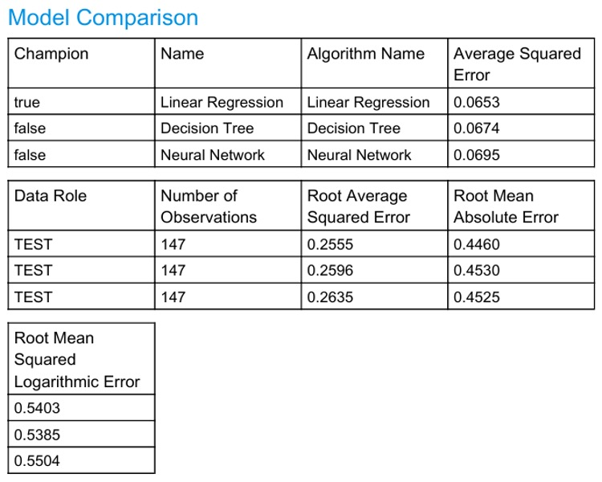
Fig. 11. Model comparison results from SAS Viya.

V. INTERPRETATION AND DISCUSSION
The results indicate that Linear Regression was the most suitable model for this dataset. The relationship between the input variables and Standardized_rating was captured more effectively by a linear model than by the more complex Decision Tree and Neural Network models. This shows that using more complex algorithms does not always lead to better performance when input-target correlations are weak.
VI. EXECUTIVE SUMMARY AND RECOMMENDATIONS
This project successfully predicted Amazon product ratings and identified the key factors influencing customer satisfaction, delivering an effective predictive modeling solution to support e-commerce decision making.
Key Recommendations:
It is recommended that future studies incorporate additional features such as product category, delivery time, and customer review sentiment to improve model accuracy.
It is recommended that the Linear Regression model be adopted for product rating prediction, as it demonstrated the lowest prediction error (ASE = 0.0653) among all evaluated models.
Future research should extend this analysis to other e-commerce platforms and regions to validate the generalizability of these findings.
It is also recommended that longitudinal data be included in future studies to capture changes in ratings and discount patterns over time.
VII. STRENGTHS AND LIMITATIONS
Strengths:
• Clear identification of the most important predictor: Discount_Percentage_Num.
• Linear Regression identified as the best model with the lowest error across all metrics.
• Clean, well-organized data with no quality issues.
Limitations:
• No time-based data; cannot track ratings or discount changes over time.
• Data is from Amazon India only; findings may not apply to other platforms or regions.

VIII. ETHICAL CONSIDERATIONS
Data was used responsibly, privacy was respected, and limitations were transparently reported.
• Data Privacy – No personally identifiable information was used.
• Transparency – All limitations are openly reported.
• No Manipulation – Results reported honestly without selective reporting.
• Fair Representation – No products or categories were excluded to favor any outcome.
IX. CONCLUSION
This project successfully compared three machine learning models on the Amazon Sales Dataset using SAS Viya Model Studio. Linear Regression was selected as the best model (ASE = 0.0653), confirming that simpler models can outperform complex ones when input-target correlations are weak. The findings provide actionable insights for e-commerce rating prediction and discount strategy optimization.
REFERENCES
[1] Kaggle. (n.d.). Amazon Sales Dataset. Retrieved from https://www.kaggle.com/code/mehakiftikhar/amazon-sales-dataset-eda
[2] SAS Institute Inc. (2024). SAS Viya: Model Studio User’s Guide. Cary, NC, USA: SAS Institute Inc.

